Anyone is welcome as a member!
Each member has one equal vote at general meetings and can put themselves forward as a board member when there are vacancies.
As we are a Community Benefit Society, every member needs to own one or more shares in it. The cost of a share is just £1, there is no obligation to invest more.
That means you can join us for as little as £1.
However, to help us become more established
you are welcome to buy as many £1 shares as you wish.
Once projects are under way, we will be able to raise more money through a separate community share offer.
Please join us! Complete and return the application form with your share subscription.
Thank you,
Phyllida Culpin, Secretary
Becoming a Member
Please note that as we are at the set-up stage of our Society, we are particularly
hoping to find members willing and able to actively support us.
Bridport Area Community Housing Ltd. is registered under the Co-operative and Community Benefit Societies Act 2014 as a Community Benefit Society, Registered Number 8493. Registration date: 4th November 2020
Address: Mountfield, Rax Lane, Bridport, Dorset, DT6 3JP

Membership of Bridport Area Community Housing : Side 1, Applicant’s Personal Details

Title First name(s)
Surname
Postal Address

Post code
E-mail address Phone (optional)

Bridport Area Community Housing is supported by Bridport Town Council and Wessex Community Assets and we may share your data with these partners but only for matters relating to Bridport Area Community Housing.
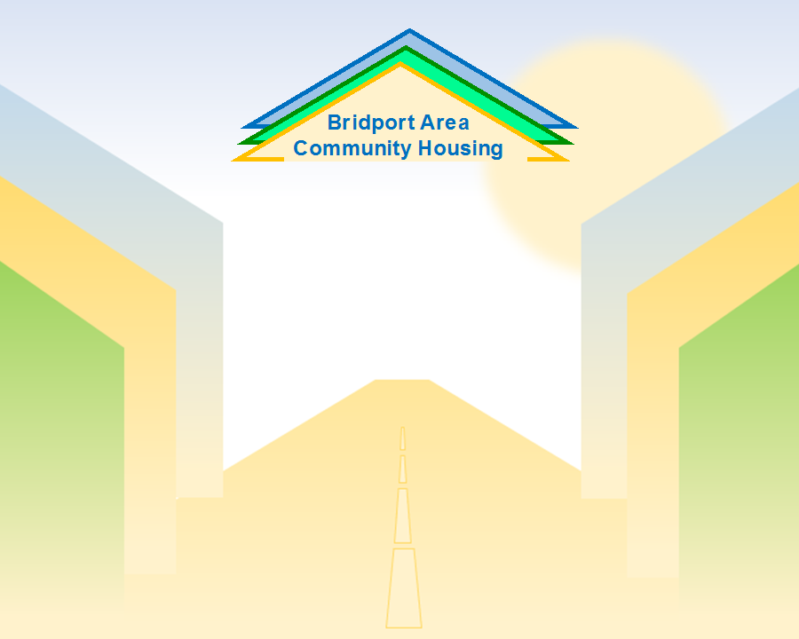
You may deliver by hand or post your completed application on paper to:
Bridport Area Community Housing
c/o Bridport Town Council, Mountfield, Bridport, DT6 3JP

Or, you may email a scanned copy or a digital photo of both sides of the completed form to our Secretary:
info@bridportach.org.uk

Payment for your share(s) may be made:
On-line to our account at the Unity Trust Bank, Sort Code 60-83-01, Account Number 20436298, quoting your name as a reference.
Alternatively, should you prefer to pay in cash we will keep a record of payments due, and collect when Covid restrictions allow us to meet. (If you are delivering by hand then cash can be enclosed if you wish).
Following acceptance of membership, a Share Certificate will be issued (initially via email, originals can be collected as Covid restrictions permit).


Membership of Bridport Area Community Housing: Side 2, Declaration and Signature
I __________________________________________(full name) support the objectives of Bridport Area Community Housing and wish to apply to become a member. I understand that:  - I must purchase at least one share of a minimum £1 value.  - I have one vote at general meetings regardless of how many shares I hold.  - The payment for a share, or shares, is the limit of my liability to Bridport Area Community Housing. There will be no dividend payable to shareholders as, unlike a share in a commercial company, members will not ‘own’ part of Bridport Area Community Housing.  - If I wish to leave the Society, I may not get any or all of my money back.  - By becoming a member, I am signing up to the Rules (which can also be provided electronically on request) and other governing documents of Bridport Area Community Housing. | I agree to Bridport Area Community Housing holding and processing my personal data for the purposes set out in, and in accordance with, our Data Protection Privacy Notice (which can also be provided electronically on request).  This application will be considered by the Bridport Area Community Housing Board and acceptance will be at the Board’s absolute discretion.  Together with the completed Personal Details section I submit this application for ………….... share(s) with my payment of £………………..., being £1.00 per share, via on-line bank draft, or in cash when Covid restrictions permit [delete as appropriate].  Signed  Date
Becoming a member

